Project Design Phase-II
Technology Stack (Architecture & Stack)

Date | 07 March 2026
Team ID | Sumit Yadav, Bipin Kole, Sagar Shrikant, Vaishnavi Khot
Project Name | Plugging into the Future: An Exploration of  Electricity Consumption Patterns Using Tableau
Maximum Marks | 4 Marks

Technical Architecture:
The Deliverable shall include the architectural diagram as below and the information as per the table1 & table 2
Example: Order processing during pandemics for offline mode
Reference: https://developer.ibm.com/patterns/ai-powered-backend-system-for-order-processing-during-pandemics/
Guidelines:
Include all the processe s (As an application logic /
Technology Block)
Provide infrastructural demarcation (Local / Cloud)
Indicate external interfaces (third party API’s etc.)
Table-1 : Components & Technologies:
Indicate Data Storage components / services Indicate interface to machine learning models (if
Tableapplicabl-2: Application Characteristicse) :

References:
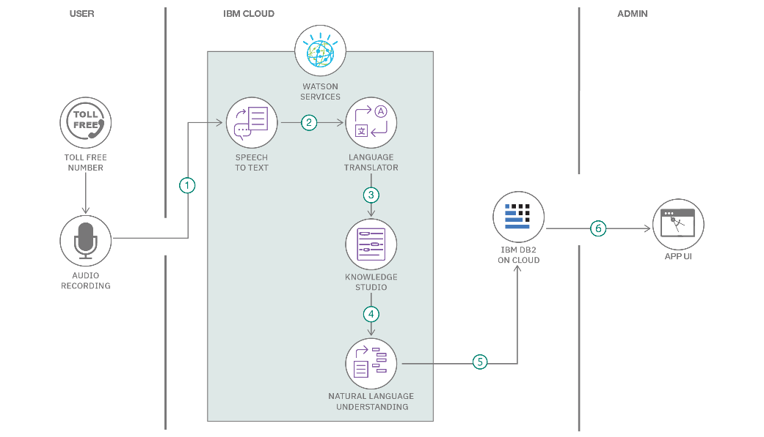

S.No | Component | Description | Technology
1 | User Interface | Dashboard interface for viewing electricity consumption trends | Tableau Public
2 | Application Logic-1 | Script for data cleaning and formatting | Python (Pandas, NumPy)
3 | Application Logic-2 | Data reshaping and exporting for Tableau | Python
4 | Database | Processed CSV/Excel  files | Local Filesystem
5 | Cloud Database | N/A – Static files used in Tableau | N/A
6 | File Storage | Stores preprocessed datasets | Local Storage
7 | External API-1 | Open energy datasets | data.gov.in, Kaggle
8 | External API-2 | Weather correlation data (optional) | OpenWeather API
9 | Machine Learning Model | Optional forecasting model (future scope) | Prophet / Scikit-learn
10 | Infrastructure | Application setup and dashboard hosting | Local preprocessing + Tableau Cloud

S.No | Characteristics | Description / Technology
1 | Open-Source Frameworks | Python (Pandas, NumPy), Tableau Public
2 | Security Implementations | Tableau’s built-in access control and published link privacy
3 | Scalable Architecture | Scalable via Tableau’s support for large datasets and filters
4 | Availability | High availability via Tableau Public’s cloud-hosted platform
5 | Performance | Fast rendering through preprocessed and optimized data, cache-enabled dashboards

https://c4model.com/
https://developer.ibm.com/patterns/online-order-processing-system-during-pandemic/ https://www.ibm.com/cloud/architecture https://aws.amazon.com/architecture
https://medium.com/the-internal-startup/how-to-draw-useful-technical-architecture-diagrams-2d20c9fda90d

